
Email:milleniumstar.enterprise@ymail.com Telefax:(049)5081582

QUOTATION
To:Pricon MSE080520
Attn:Ms.Rebecca Valenzuela August 5,2020
CC: Mr.Arnold Martinez/Mr.Aljhon Anonuevo
Subject:inquiry
Ma’am
We are pleased to quote you as follows. We highly appreciated your interest in our company.
And we are looking forward in seeing your purchase order.Thank you very much for your inquiry.
ITEM QTY. DESCRIPTION Unit Price Total Amount
1 2pcs Band heater Usd220.00/pc Usd440.00
Inside Diameter mm : 56
Width mm: 77
Power watts : 695
Stainless mica with ceramic insulation
Delivery:2weeks
Price :DDU
Terms:End of next month after the month end closing

If you have any queries please don’t hesitate to contact us.
Sincerely ,
Johnna Villaceran
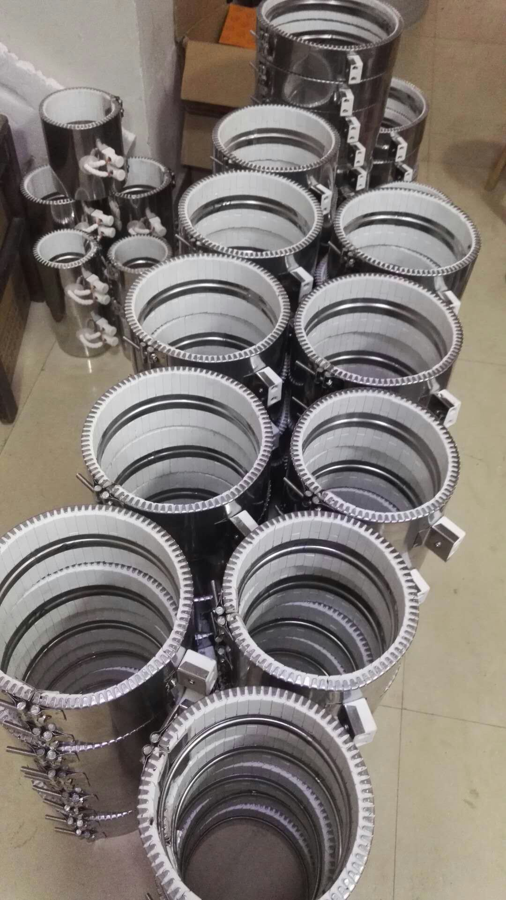

Delivery:2weeks
Price :DDU
Terms:End of next month after the month end closing

If you have any queries please don’t hesitate to contact us.
Sincerely ,
Johnna Villaceran

